The Cognitive-Bayesian Adaptive Architecture Framework
Executive Summary
The Cognitive-Bayesian Adaptive Architecture (CBAA) Framework addresses a critical gap in today's architectural approaches. As organizations face unprecedented technological change, particularly with AI integration, traditional frameworks like TOGAF and Zachman are proving inadequate—they prioritize documentation over adaptability and fail to address human cognitive limitations.
The CBAA Framework synthesizes cognitive psychology, evidence-based decision making, and adaptive systems thinking into a cohesive architectural model that works with rather than against human cognition. This human-centered approach acknowledges uncertainty as an inherent property to be systematically managed rather than an exception to be eliminated.
Key Innovations
The framework introduces five core principles that fundamentally transform architecture practices:
- Cognitive Optimization: Designs systems that work with human cognitive capabilities rather than against them
- Adaptive Uncertainty Management: Systematically addresses variability and ambiguity through evidence-based approaches
- Business Value Adaptation: Continuously aligns architectural decisions with evolving business needs
- System Adaptivity: Treats change as a first-class architectural concern rather than an exception
- Cross-Domain Integration: Bridges technology, business, and organizational boundaries

Introduction
The modern technology landscape requires a fundamentally new approach to architectural design. Traditional frameworks struggle with rapid change, cognitive complexity, and the increasing integration of AI into systems. This research presents the Cognitive-Bayesian Adaptive Architecture (CBAA) Framework—a novel architectural model synthesizing psychological principles, Bayesian reasoning, and interdisciplinary methodologies to create highly adaptable technology systems across enterprise and solution levels.
The Architecture Crisis Facing Modern Organizations
Technology architectures today face unprecedented challenges from rapidly evolving technologies, especially AI, which render traditional static architectural approaches ineffective. Existing frameworks like TOGAF, Zachman, and FEAF prioritize comprehensive documentation over adaptability, struggle with enterprise-wide scope, and lack mechanisms for continuous evolution. These frameworks were designed for stable, predictable environments that no longer exist.
Modern systems require architectures that account for how humans process information (not how we wish they would), incorporate probabilistic reasoning to handle uncertainty, integrate business processes dynamically, and adapt continuously to changing environments. The CBAA Framework addresses these needs by synthesizing cognitive psychology, Bayesian statistics, and interdisciplinary systems thinking into a cohesive model for the AI age.
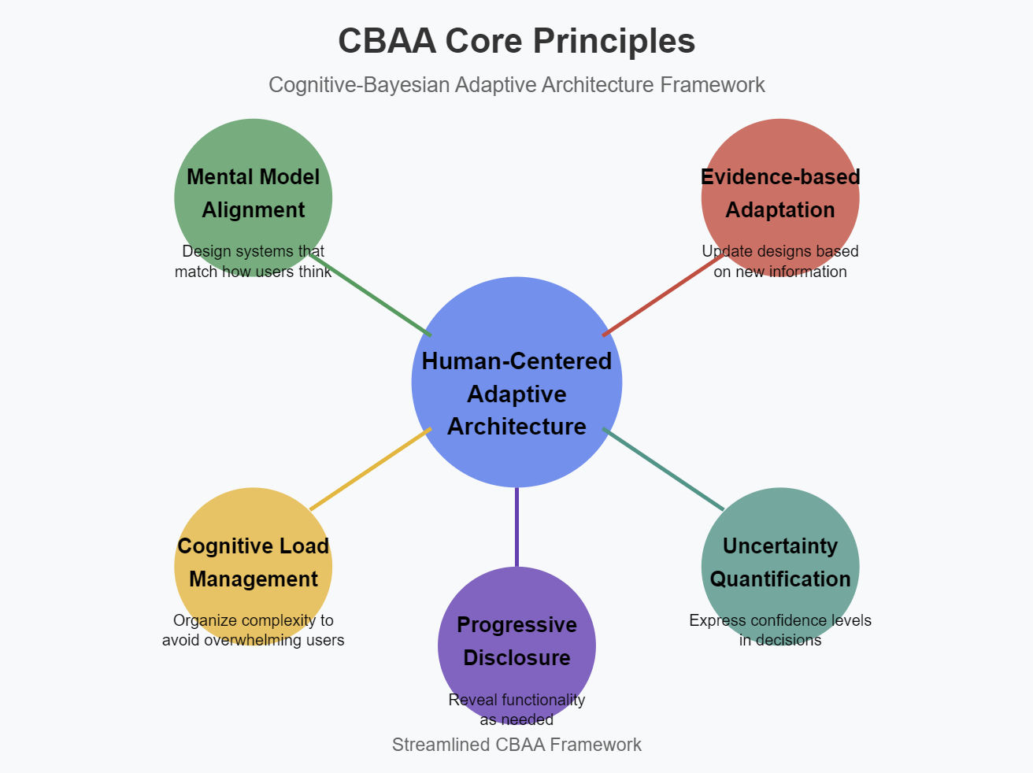

Core Principles of the Cognitive-Bayesian Adaptive Architecture Framework
1. Cognitive Optimization Principle
The CBAA Framework places human cognitive capabilities at the center of architectural design, perfecting systems to work with rather than against human cognition. Drawing from cognitive load theory, the framework aims to:
- Minimize extraneous cognitive load by cutting unnecessary complexity, inconsistent patterns, and distracting elements
- Manage intrinsic cognitive load through progressive disclosure, information chunking, and multimodal distribution
- Perfect germane cognitive load by supporting schema formation and mental model development
This cognitive-first approach ensures systems stay usable even as they grow more complex, unlike traditional frameworks that often neglect the psychological dimension of system interaction.
2. Adaptive Uncertainty Management Principle
The CBAA Framework employs structured, evidence-based approaches to systematically handle uncertainty at each architectural stage. This approach:
- Acknowledges multiple possible interpretations of requirements rather than fixed values
- Refines architectural understanding as new evidence emerges
- Explicitly addresses confidence levels in architectural decisions
- Supports decision-making under uncertainty by evaluating potential outcomes
This principle transforms how architecture handles change—from treating uncertainty as an exception to embracing it as an inherent system property that can be systematically addressed through architectural means.

3. Business Value Adaptation Principle
The framework continually aligns technology architecture with evolving business value through:
- Value stream mapping that connects architectural elements to business outcomes
- Capability-based planning that focuses on what the business needs to achieve
- Rapid feedback loops between business processes and technological implementation
- Outcome-oriented metrics that measure business impact rather than technical compliance
This principle ensures architecture serves business needs rather than becoming an end in itself—a critical shift from traditional frameworks.
4. System Adaptivity Principle
The CBAA Framework treats adaptivity as a first-class architectural concern by:
- Designing modular components that can evolve independently
- Establishing clear interfaces that enable reconfiguration
- Creating feedback mechanisms that drive continuous learning
- Building sensing capabilities that detect environmental changes
- Implementing response strategies that adjust to new conditions
This approach enables architectures to evolve continuously rather than requiring periodic replacement—essential in rapidly changing environments.
5. Cross-Domain Integration Principle
The framework integrates across technology domains (software, telephony, networks, systems) through:
- Common conceptual models that span domain boundaries
- Interface standards that enable cross-domain communication
- Unified governance approaches that keep coherence without constraining innovation
- Integration patterns that preserve domain-specific capabilities while enabling collaboration
This principle addresses the increasing convergence of technology domains that traditional architectures struggle to manage.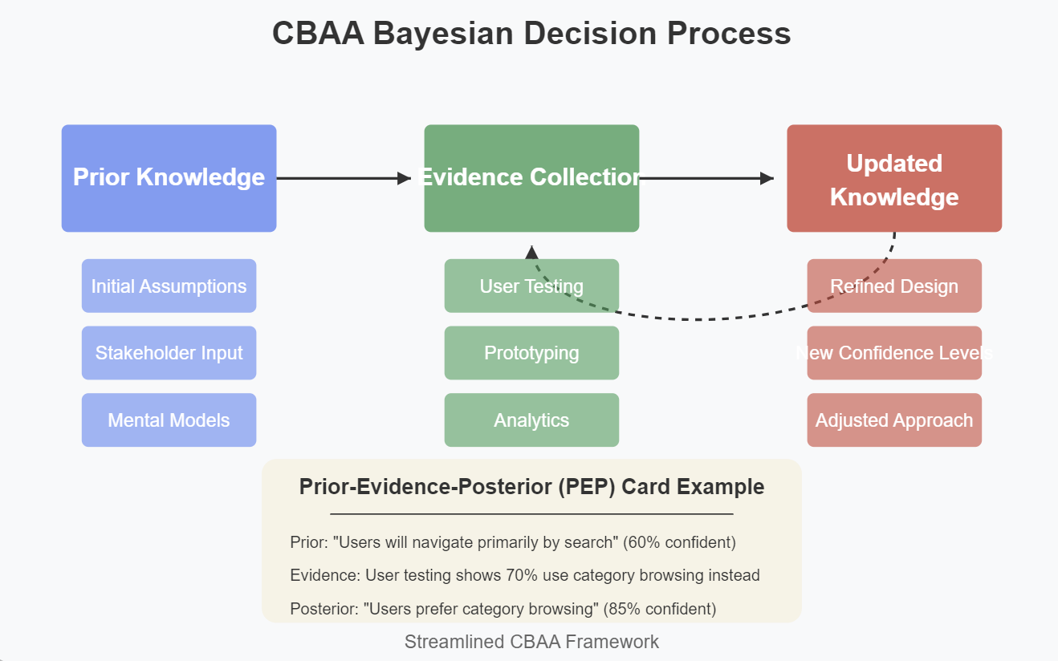

The CBAA Architectural Process
The CBAA process model differs fundamentally from traditional architectural approaches by incorporating cognitive, Bayesian, and adaptive elements at each stage:
Phase 1: Intent Definition
This phase sets up architectural purpose through:
- Stakeholder empathy mapping to understand cognitive and emotional needs
- Value stream identification to connect architecture to business outcomes
- Prior probability elicitation to capture existing knowledge and assumptions
- Capability modeling to define what the organization needs to accomplish
- Cognitive assessment to understand user mental models and expectations
Integration Point: This phase sets up the foundational knowledge base for the entire architecture by capturing stakeholder needs, business goals, and existing system context, creating a comprehensive baseline that will evolve throughout the architectural lifecycle.
Phase 2: Discovery & Analysis
This phase develops understanding of the current state through:
- Systems mapping to visualize relationships between components
- Cognitive workload analysis to find information processing bottlenecks
- Value flow analysis to trace how business value is created and delivered
- Technology landscape assessment to understand capabilities and constraints
- Uncertainty identification to explicitly recognize knowledge gaps
Integration Point: Discovery findings transform initial assumptions into evidence-based insights, refining the architecture's probabilistic model and revealing critical areas of certainty and uncertainty.

Phase 3: Concept Development
This phase creates possible architectural approaches through:
- Scenario development to explore multiple possible futures
- Pattern identification to use proven solutions
- Modular decomposition to create adaptable components
- Interface definition to enable part interaction
- Cognitive model alignment to match user expectations
Integration Point: Concept development translates probabilistic understanding into concrete architectural options, using expected utility analysis to find approaches that balance stakeholder value with implementation feasibility.
Phase 4: Validation & Refinement
This phase tests architectural concepts through:
- Prototype development to create tangible representations
- Cognitive testing to assess information processing requirements
- Simulation to model system behavior under different conditions
- Stakeholder feedback to ensure alignment with needs
- Bayesian updating to refine probability distributions based on new evidence
Integration Point: Validation activities generate empirical evidence that reduces key uncertainties, allowing the architecture to converge toward solutions with higher confidence levels while finding areas requiring further investigation.
Phase 5: Implementation & Evolution
This phase realizes and adapts the architecture through:
- Incremental implementation to deliver value continuously
- Feedback collection to understand actual system performance
- Learning mechanisms to capture insights from experience
- Adaptation processes to respond to changing conditions
- Continuous probability updating to refine understanding
Integration Point: Real-world implementation creates a continuous learning system where operational data drives architectural evolution, ensuring the architecture stays aligned with actual performance rather than theoretical predictions.
Cognitive Load Optimization Techniques
The CBAA Framework incorporates specific techniques from cognitive load theory to perfect system usability:
1. Progressive Information Architecture
This technique organizes information in layers that can be progressively accessed:
- Core information visible at top level (4–7 key elements)
- Related information accessible through progressive disclosure
- Detailed information available on demand
- Information hierarchy aligned with importance and frequency of use
Research Basis: Studies by Sweller (2011) prove that progressive disclosure reduces extraneous cognitive load by limiting information to what's relevant at each decision point.

2. Contextual Intelligence
This technique presents information based on user context:
- Task-relevant information prominently displayed
- Irrelevant information minimized or hidden
- Adaptations based on user ability level
- Information density adjusted to cognitive capacity
Research Basis: Cognitive research by Kahneman (2011) shows that context-sensitive information presentation significantly reduces cognitive effort and error rates.
3. Consistent Pattern Libraries
This technique develops and keeps consistent interaction patterns:
- Standard terminology across system components
- Consistent visual language and interaction models
- Pattern reuse to use existing mental models
- Common frameworks that span technology domains
Research Basis: Studies in recognition memory by Baddeley (2007) prove that consistency enables recognition over recall, reducing cognitive load.
4. Multimodal Distribution
This technique distributes information across modalities:
- Visual information for spatial relationships
- Textual information for precise details
- Auditory information for alerts and notifications
- Interactive elements for complex relationships
Research Basis: Cognitive load research by Mayer (2009) shows that distributing information across modalities effectively expands working memory capacity.
Bayesian Decision Support System
The CBAA Framework includes a Bayesian decision support system that guides architectural decisions under uncertainty:
1. Probabilistic Knowledge Representation
This part represents architectural knowledge as probability distributions:
- Requirements represented as distributions over possible interpretations
- Component capabilities modeled as distributions over performance characteristics
- Integration risks captured as probability distributions over potential issues
- Business value expressed as distributions over possible outcomes
Implementation: These distributions are stored in a knowledge base that supports Bayesian inference and updating.
2. Architectural Insight Collection
This part systematically gathers information to refine architectural understanding:
- Structured capture of stakeholder feedback and experiences
- Systematic testing of architectural assumptions and approaches
- Integration with operational metrics and business outcomes
Implementation: The insight collection system includes protocols for ensuring information quality, relevance to architectural questions, and proper influence on design decisions.
3. Adaptive Learning Component
This component refines architectural understanding based on new information:
- Systematic methods for integrating new evidence with existing knowledge
- Support for various types of architectural information and contexts
- Handling of dependencies between architectural elements and decisions
- Visualization of evolving architectural understanding
Implementation: The learning component uses structured evaluation techniques to handle complex architectural relationships and trade-offs, supporting incremental refinement of designs.
4. Decision Analysis Tools
This component supports architectural decision-making:
- Trade-off analysis for comparing alternative approaches
- Value assessment to prioritize information gathering activities
- Sensitivity analysis to identify critical design decisions
- Adaptability analysis to evaluate performance across various scenarios
Implementation: These tools provide interactive visualizations that help architects understand the implications of their decisions and design for appropriate flexibility.
Cross-Domain Integration Model
The CBAA Framework includes specific mechanisms for integrating across technology domains:
1. Domain-Neutral Capability Model
This model defines capabilities in domain-independent terms:
- Business capabilities that describe what the organization needs to accomplish
- System capabilities that describe how technology supports business capabilities
- Capability decomposition that connects high-level capabilities to specific implementations
- Capability maturity assessment that evaluates current performance
Implementation: The capability model serves as a bridge between business needs and technological implementations across domains.
2. Interface Definition Framework
This framework specifies how components interact across domains:
- Standard communication protocols for cross-domain interaction
- Data models that maintain semantic consistency
- Service contracts that define expectations and requirements
- Integration patterns for common cross-domain scenarios
Implementation: The interface definition framework ensures that components can collaborate effectively regardless of their domain.

3. Cross-Domain Governance Model
This model maintains coherence across domains without constraining innovation:
- Shared principles that guide decisions across domains
- Domain-specific standards that address unique requirements
- Cross-domain coordination processes for managing dependencies
- Adaptive governance that adjusts based on domain characteristics
Implementation: The governance model balances the need for consistency with the need for domain-specific optimization.
Implementation Considerations
1. Organizational Readiness
Implementing the CBAA Framework requires organizational capabilities:
- Experience with adaptive systems design
- Comfort with cross-functional collaboration
- Willingness to embrace uncertainty and continuous learning
Organizations should assess their readiness and develop these capabilities as needed.

2. Incremental Adoption
The framework can be adopted incrementally:
- Start with a specific business capability or solution area
- Apply selected principles rather than the entire framework
- Build experience with cognitive optimization techniques
- Gradually introduce Bayesian decision support
- Expand to additional domains as confidence grows
Incremental adoption reduces risk and builds organizational capability gradually.
3. Tool Support
Various tools can support framework implementation:
- Modeling tools that support probabilistic representation
- Simulation environments for testing architectural concepts
- Monitoring systems that gather evidence for Bayesian updating
- Collaboration platforms that facilitate cross-domain integration
- Knowledge management systems that capture architectural decisions

Case Studies of Similar Approaches
While the complete CBAA Framework represents a new integration of approaches, elements have been successfully applied in various organizational contexts:
IKEA's Enterprise Operating Model
IKEA has developed an enterprise architecture that aligns people, processes, and organizational structure:
- Cross-functional teams organized around customer journeys rather than functional silos
- Decision-making frameworks that adapt based on context and complexity
- Knowledge sharing mechanisms that distribute cognitive load appropriately across teams
- Governance processes that evolve based on operational feedback and market conditions
This architectural approach has enabled IKEA to maintain consistent customer experience while adapting to regional market differences and changing consumer behaviors.

Singapore's Public Service Architecture
Singapore's government has implemented an adaptive public service architecture that:
- Structures ministries and agencies around citizen-centered capability models
- Uses evidence-based approaches to evaluate policy and service delivery options
- Integrates feedback loops between frontline workers and policy development
- Continuously evolves organizational structures based on emerging citizen needs
This architectural model has enabled Singapore to maintain service excellence while navigating complex societal challenges and changing citizen expectations.

Mayo Clinic's Integrated Care Delivery System
Mayo Clinic has developed a care delivery architecture that focuses on people and processes:
- Clinical knowledge structures organized around patient-centered care pathways
- Team compositions that optimize cognitive load distribution between specialists
- Decision support frameworks that integrate insights across medical disciplines
- Organizational learning systems that adapt protocols based on outcome data
This architectural approach has improved both patient outcomes and provider effectiveness by creating a coherent system where organizational structures, processes, and knowledge management are aligned toward common goals.

Conclusion
The Cognitive-Bayesian Adaptive Architecture Framework represents a fundamental shift in architectural thinking—from static, documentation-focused approaches to dynamic, human-centered, adaptive architectures. By integrating cognitive psychology, Bayesian reasoning, and interdisciplinary systems thinking, the framework addresses the limitations of traditional architectural models while enabling organizations to thrive in rapidly changing environments.
The framework doesn't merely add features to existing approaches—it reconceptualizes architecture as a continuously evolving system that learns from experience, adapts to changing conditions, and optimizes for human cognitive capabilities. This shift is essential for organizations navigating the complexities of modern technology landscapes, particularly with the rapid advancement of AI and other transformative technologies.
Organizations that adopt this framework will develop architectures that not only survive disruption but harness it as a driver of innovation and value creation. The CBAA Framework provides the foundation for technology systems that adapt continuously, engage humans effectively, and deliver sustained business value in an era of unprecedented change.

